

**Software Engineering Department  
Braude College**

**Capstone Project Phase A – 61998**

25-1-D-23

Innovating Traffic Control – Smart Traffic Lights Powered by Digital Twin Models

**Advisor:**

**Mr. Uzi Rosen**

**Authors :**

**Amni Abo Samra**

**Hamza Abu Nimer**

**git repository :** [**https://github.com/AmniAbo/Final-Project.git**](https://github.com/AmniAbo/Final-Project.git)

**Table of Contents**

**1.Introduction 3**

**2. Literature Review 3**

2.1 Digital Twin Technology 3

2.2 Features of Digital Twin in Industry 4.0 4

2.3 Digital Twin Applications Across Industries 7

2.4 The Necessity of a Digital Twin 8

2.5 Innovations in Digital Twin Technology: 9

2.6 Future Directions of Digital Twin Technology: 9

**3. Reviewing the Need 10**

**4. Existing Technologies 11**

4.1 Comprehensive Overview of Current Tools and Methods 13

4.2 Explanation of Evaluation Criteria 15

4.3 Why STT was found to be the best solution 16

**5. Proposed Solution 18**

5.1 Core Components: 18

5.2 Implementation Strategy 19

5.3 Key Benefits: 20

**6. Expected Achievements 22**

6.1 Outcomes 22

6.2 Criteria for Success: 23

**7. Development Process 24**

7.1 Research and Analysis 24

7.2 Data Requirements and Technology Integration 25

7.3 Constraints and Challenges 32

7.4 Functional and Non-Functional Requirements 33

7.5 Use Case Diagram 37

**8. Design and Development 38**

8.1 Visualizing the System Architecture: Diagrams and Flowcharts 38

8.2 Implementation of IoT and Sensors 40

8.3 AI Model Development 42

8.4 Digital Twin Simulation 43

8.5 Web Interface for Traffic and Environmental Data 44

**9. Verification and Evaluation 46**

9.1 Evaluation 46

9.2 Verification 46

9.3 Test Cases 47

**10. AI Tools and Prompts 49**

**11. References: 50**

**Abstract**

Digital Twin technology is revolutionizing various industries by enabling real-time simulation, analysis, and optimization of physical systems. This project demonstrates the practical application of Digital Twin technology through a smart traffic light system, showcasing its potential to enhance urban mobility and infrastructure planning.

By developing a continuously evolving virtual model of intersections, the proposed system integrates real-time data acquisition, AI-driven analytics, and IoT connectivity. This bi-directional interaction between physical and virtual environments allows for dynamic traffic signal adjustments based on congestion levels, weather conditions, and the presence of emergency vehicles and pedestrians, providing a data-driven approach to traffic management.

A key advantage of this system is its predictive capability. Leveraging machine learning algorithms, it analyzes historical and real-time traffic data to detect emerging patterns and proactively adjust signal timing, preventing congestion before it occurs. Additionally, the system enhances pedestrian safety through adaptive crossing algorithms that prioritize pedestrian flow in high-traffic areas while maintaining vehicular efficiency.

Rather than aiming to completely resolve urban congestion, this research highlights the transformative role of Digital Twin technology in real-time decision-making, predictive analytics, and adaptive traffic control. By demonstrating its practical implementation, this project underscores the power of Digital Twin technology in shaping intelligent, data-driven urban mobility solutions and infrastructure planning.

# 

# 

# 

# **1.Introduction**

As urban populations grow and vehicle density increases, traditional traffic management systems struggle to adapt to real-time conditions. This results in inefficiencies, delays, and safety concerns, particularly at busy intersections where fixed traffic signals fail to accommodate fluctuating traffic and pedestrian needs.

The primary goal of this project is to develop a smart traffic light system as a demonstration platform for Digital Twin technology. Through this project, we showcase how Digital Twin integrates real-time data collection, advanced analytics, and AI to optimize traffic and pedestrian management. The solution will enable dynamic adjustment of traffic signals based on live traffic data, improving flow and reducing congestion. It will also enhance pedestrian safety by providing adaptive signal timings and real-time monitoring for safer crossings. The ultimate goal is to create a more efficient, safe, and sustainable transportation system that adapts to the needs of both pedestrians and drivers in urban environments.

To address these challenges, emerging technologies, particularly Digital Twin technology, offer innovative solutions for dynamic and efficient traffic management. This section delves into the principles of Digital Twin technology and its transformative role in optimizing traffic systems, drawing on existing research to explore its potential applications in urban mobility.

For ease of reference, the project will be referred to as *Smart Traffic Twin or STT* throughout the paper.

# **2. Literature Review**

The rapid evolution of urban mobility has necessitated the development of advanced traffic management solutions that go beyond traditional, pre-programmed signal systems. Emerging technologies such as the Internet of Things (IoT), artificial intelligence (AI), and real-time data analytics have paved the way for smarter, more adaptive traffic control mechanisms. Among these, Digital Twin technology stands out as a transformative approach that enables real-time simulation, monitoring, and optimization of traffic systems. This section explores the fundamental principles of Digital Twin technology, its role in modern traffic management, and its broader applications within the framework of Industry 4.0. Through a comprehensive review of existing research, we highlight the key benefits, challenges, and opportunities associated with integrating Digital Twins into urban transportation networks.

## **2.1 Digital Twin Technology**

A digital twin is a virtual representation of a physical object, system, or process that is intended to mimic its real-world counterpart through ongoing data exchange and analysis. This technology combines the IoT, AI, and data analytics to generate dynamic models that reflect physical entities' performance, operation, and behavior in real time.

Digital twin technology revolutionizes how systems and environments are modeled, monitored, and optimized. By simulating and analyzing behaviors and conditions in a digital environment, digital twins offer unparalleled insights and predictive capabilities.

The figure below highlights the distinctions between a Digital Model, Digital Shadow, and Digital Twin, showcasing their respective roles and information flow:

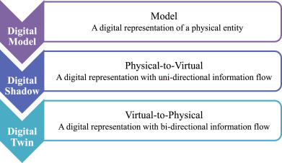

*Figure 1: Differences between Digital Models, Digital Shadows, and Digital Twins.*

A Digital Model represents a static digital version of a physical entity(Figure1). A Digital Shadow introduces uni-directional information flow, where data flows from the physical to the virtual. Finally, a Digital Twin establishes bi-directional information flow, allowing both simulation and real-time updates to influence the physical entity(Figure1).

## **2.2 Features of Digital Twin in Industry 4.0**

With this understanding of digital twin fundamentals, let's examine how this technology integrates within Industry 4.0 and its broader industrial applications.

### **2.2.1 Overview of Industry 4.0**

Industry 4.0 builds on previous industrial revolutions by integrating IoT, AI, and cloud computing, enabling smart factories with real-time data analysis and self-optimizing systems. In contrast, Industry 3.0 introduced automation and robotics, Industry 2.0 focused on mass production using electricity, and Industry 1.0 marked the shift from manual labor to mechanized steam-powered production(Figure2).

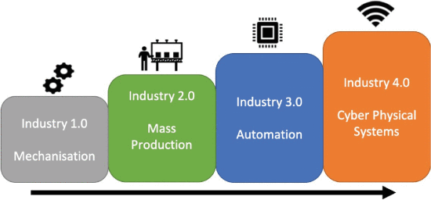

*Figure 2: The evolution of industrial manufacturing*

The Digital Twin plays a pivotal role in enabling Industry 4.0 by creating virtual replicas of physical systems, processes, or products. These features (Figure3) enhance operational efficiency, facilitate predictive insights, and enable real-time monitoring and analysis, as detailed below:

1. Data Collection

Digital twins collect vast amounts of real-time data through sensors, IoT devices, and connected systems. This data serves as the foundation for analyzing processes, monitoring performance, and predicting outcomes.

1. Analysis

Digital twins analyze operational data to gain insights into system performance and detect areas of improvement. Advanced AI and ML models help in understanding patterns, forecasting failures, and optimizing operations.

1. Opportunities

Digital twins create opportunities to innovate and improve efficiency. They allow virtual testing of ideas, helping organizations explore potential improvements without disrupting live systems.

1. Maintenance History

Digital twins store detailed records of maintenance history, enabling predictive maintenance strategies. By identifying trends and root causes of failures, they minimize downtime and extend asset lifespan.

1. Collaboration Network

Digital twins enable collaboration across teams by providing a shared digital model. Engineers, operators, and decision-makers can work together seamlessly, leading to enhanced problem-solving and decision-making.

1. Learning

By continuously learning from real-time and historical data, digital twins adapt and improve their accuracy. Machine learning models help in developing systems that evolve over time for better predictions.

1. Product Behaviors

Digital twins monitor and simulate product behavior under different conditions. They help evaluate product performance, identify design flaws, and optimize functionality.

1. Operational History

Digital twins maintain an operational history of systems and processes. This information helps analyze past performance, understand trends, and optimize future operations for efficiency and reliability.

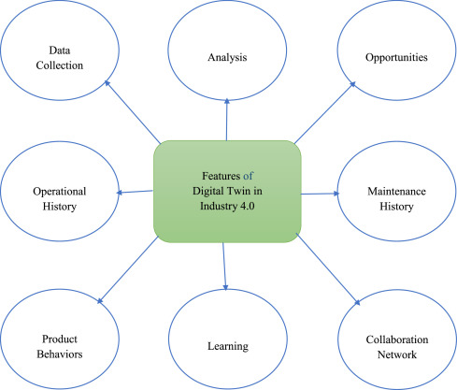

*Figure 3: Key Features of Digital Twin in Industry 4.0*

These features of digital twins form the basis for a structured implementation process in industrial settings.

### 

### **2.2.2 The Process Used in Digital Twin for Industry 4.0**

The process used in Digital Twin for Industry 4.0 involves the following steps:

1. Cloud-Based IIoT Platform: Digital twins use cloud-based IIoT platforms to monitor, train, and assist remotely.
2. High-Fidelity Virtual Models: Real-time adaptations are made to virtual models to mirror changes in the physical environment.
3. Simulation and Forecasting: Behavioral simulations allow prediction of asset and process changes under various conditions.
4. Real-Time Monitoring: Digital twins bridge the physical and digital worlds, enabling remote monitoring and operations.
5. Operational Benefits: Companies achieve enhanced operations, reduced downtime, and faster innovation cycles.

As we move forward, let's look at the broader applications of Digital Twin technology across different industries, illustrating its transformative impact.

## **2.3 Digital Twin Applications Across Industries**

The following diagram illustrates the broad range of industries where digital twin technology is applied

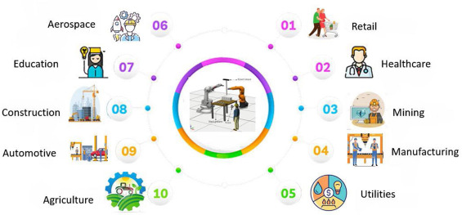

*Figure 4: Ten major industry sectors utilizing digital twin technology.*

As seen in (Figure 4), digital twins are widely adopted across various industries, enabling advancements in efficiency, monitoring, and process optimization.

#### **2.3.1 Key Use Cases and Applications of Digital Twins**

The table below outlines common applications of digital twins across different fields, showcasing their ability to enhance operations and decision-making.

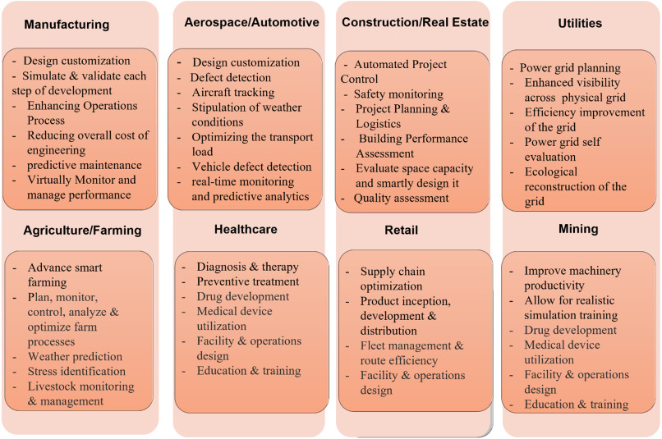

*Figure 5: Key digital twin applications across different industrial sectors*

These examples in Figure5 illustrate the significant impact of digital twins in driving innovation and optimizing performance across multiple industries.

## **2.4 The Necessity of a Digital Twin**

Digital twin technology plays a crucial role in modern engineering and operations by enhancing system design, predictive maintenance, and lifecycle management. It provides real-time feedback and advanced analytics to improve efficiency, reduce costs, and optimize performance.

1. Accelerating the Design Process  
   Engineers can accelerate the design process and eliminate laborious stages typically required when creating a new product by employing 3D simulations enhanced by augmented and virtual reality. Digital twins allow real-time adjustments to system designs without requiring costly prototypes, ensuring early problem detection and cost savings.
2. Predictive Maintenance and Optimization
   * Real-Time Monitoring: Digital twins gather operational data, including real-time feedback, historical analysis, and maintenance records, to predict failures and optimize performance.
   * Downtime Reduction: By providing automated digital checks, digital twins reinforce scheduled maintenance and reduce unexpected downtime, improving asset utilization.
3. Lifecycle Insights  
   Digital twins provide insights throughout an asset’s lifecycle, enabling:
   * Virtual Testing: Engineers test system modifications in virtual simulations before implementing them in real-world operations.
   * Stress and Environmental Analysis: Systems can be analyzed under varying stressors and conditions, providing valuable feedback to mitigate unintended consequences.

By enabling smarter decision-making and resource optimization, digital twin technology enhances intelligent automation and supports large-scale integration across industries. Its ability to provide accurate simulations and real-time adjustments makes it a critical tool for improving operational efficiency and long-term system sustainability.

## **2.5 Innovations in Digital Twin Technology:**

Recent advancements in digital twin technology include the integration with AI and machine learning algorithms, which enhance data analysis and predictive modeling capabilities. This integration allows digital twins to not only replicate physical systems but also simulate future scenarios and optimize processes dynamically. In the manufacturing industry, digital twins are being used to create highly detailed models of production lines, leading to improvements in product quality and reduced downtime. In healthcare, digital twins are advancing personalized medicine by creating virtual models of individual patients.

## **2.6 Future Directions of Digital Twin Technology:**

The future of digital twin technology is headed towards greater integration with emerging technologies such as AI, IoT, and blockchain, which will enhance its capabilities in real-time data processing and security. The technology is expected to expand its applications in areas such as smart cities, autonomous vehicles, and renewable energy systems, driving innovation and efficiency across multiple industries. As digital twins continue to evolve, they will play a crucial role in creating more efficient, sustainable, and resilient systems.

# 

# **3. Reviewing the Need for Digital Twin-Based Traffic Management Systems**

Given the challenges posed by traditional traffic management solutions, it is crucial to explore emerging technologies that offer real-time adaptability and predictive capabilities. Digital Twin technology presents an innovative approach that integrates real-time data, AI-driven analytics, and advanced simulations to optimize traffic flow and enhance pedestrian safety.

The need for innovative traffic management systems has been extensively discussed in academic and professional literature, primarily due to the limitations of existing technologies and the growing challenges in urban transportation [1]. As cities expand and the number of vehicles increases, traditional traffic control systems struggle to adapt to dynamic real-time conditions, leading to difficulties in efficiently managing unpredictable congestion, extreme weather conditions, and pedestrian safety risks [16]. These systems are typically based on reactive mechanisms and predefined rules, which limit their ability to dynamically optimize traffic flow and respond swiftly to unexpected disruptions [17].

To address these limitations, adaptive traffic signal systems have been developed to improve transportation efficiency. However, these systems often rely on static sensors and lack advanced predictive capabilities, making them insufficient for effectively handling the diverse and evolving conditions of urban environments [2]. Similarly, weather-adaptive traffic management systems have demonstrated effectiveness in reducing delays caused by extreme weather conditions, yet they remain isolated solutions that are not integrated into a holistic traffic and pedestrian management framework [8].

In recent years, digital twin technology has gained widespread recognition for its ability to provide a dynamic virtual model of physical systems, continuously updated with real-time data [4]. Unlike traditional traffic control systems, digital twins enable seamless integration of data, advanced simulations, and accurate forecasting of future traffic scenarios [4]. By incorporating IoT sensors, artificial intelligence, and predictive traffic algorithms, digital twin technology can analyze vehicle and pedestrian movement in real-time, facilitating intelligent decision-making regarding traffic signal adjustments and congestion mitigation [11]

The system can run simulations to predict future bottlenecks, allowing authorities to proactively manage traffic flow and prevent unnecessary congestion [13]. Additionally, digital twins integrate weather conditions, accident reports, and city events to dynamically adjust traffic management strategies [4]. The system is also adaptive, continuously learning and improving its performance based on historical data and real-time updates[10].

While existing traffic management systems primarily operate reactively, responding to incidents as they occur, digital twin technology enables predictive analysis and early intervention based on big data insights, making it a transformative solution in the field of traffic management [10]. This project aims to bridge these gaps by developing an advanced traffic management system that integrates digital twin technology, AI-driven analytics, and real-time data processing [2]. This system not only responds dynamically to real-time changes but also anticipates and optimizes traffic patterns while considering all environmental parameters.

The urgent need for such an integrated and intelligent system is well-documented in academic research, emphasizing the importance of combining predictive capabilities, adaptive control mechanisms, and advanced safety features [4]. The integration of digital twin technology with advanced traffic management solutions will enhance traffic flow efficiency, reduce waiting times at intersections, lower emissions by minimizing idle times and unnecessary acceleration, improve pedestrian safety through intelligent crosswalk management, and enable rapid response to emergencies by creating alternative routes and opening priority lanes for emergency vehicles [4].

By addressing these challenges, the proposed system represents an innovative and transformative solution tailored to the demands of modern transportation, improving efficiency, safety, and urban mobility [4].

While the integration of Digital Twin technology holds promise for transforming traffic management, it is essential to first examine the existing tools and technologies that are currently being utilized in urban mobility. Understanding the capabilities and limitations of these systems provides a foundation for evaluating how Digital Twin solutions can build upon and enhance existing approaches. The following section explores current technologies, including adaptive traffic signal systems, smart cameras, and pedestrian safety features, which aim to optimize traffic flow and improve safety. This will highlight the areas where Digital Twin technology can make a significant impact by addressing gaps and providing more advanced, predictive capabilities.

# **4. Existing Technologies for Traffic and Pedestrian Management**

Modern traffic management has evolved with the integration of various technologies aimed at reducing congestion and enhancing pedestrian safety. These solutions leverage IoT sensors, AI-driven analytics, and real-time data processing to optimize traffic flow. Below are key technologies currently employed in traffic and pedestrian management, along with their primary functionalities and applications.

### Adaptive Traffic Signal Systems & Smart Cameras with Computer Vision:

These systems use sensors, cameras, AI, and computer vision to dynamically adjust traffic light timings based on real-time data. They detect vehicles and pedestrians to optimize traffic flow and prevent accidents[18].

### Smart Crosswalks & Smart Pedestrian Assistance:

Using sensors, LED lights, audio signals, and tactile feedback, these systems enhance pedestrian safety. They activate lights and provide additional features for visually impaired pedestrians, ensuring safer crossings[19].

### Pedestrian Countdown Timers:

These timers display the remaining time for pedestrians to cross safely, helping to reduce accidents. They enable pedestrians to make informed decisions about crossing streets[20].

### Vehicle-to-Everything (V2X) Communication & Autonomous Vehicle (AV) Traffic Integration:

In Vehicle-to-Everything (V2X), the "X" stands for "Everything" and represents all entities a vehicle can connect with, including vehicles (V2V), infrastructure (V2I), pedestrians (V2P), networks (V2N), the power grid (V2G), and devices (V2D).

V2X communication enables vehicles to interact with infrastructure and other vehicles for optimized traffic flow. AV integration uses V2X and real-time data to manage both autonomous and traditional vehicles at intersections[21].

### Real-Time Traffic Management Centers (TMCs):

TMCs use cameras, sensors, GPS, and live data analytics to monitor traffic in real time. This helps optimize traffic flow, adjust signal timings, and manage incidents effectively[22].

### AI Traffic Prediction Models & Dynamic Lane Control Systems:

AI models analyze historical and real-time data to predict congestion and optimize traffic flow. Dynamic lane control adjusts lane allocations based on current traffic conditions to reduce congestion[23][24].

### Connected and Autonomous Intersection Management:

Autonomous vehicle algorithms, combined with V2X communication, enable efficient traffic management at intersections. These systems optimize vehicle paths without traditional traffic lights[25].

### Dynamic Signage and Route Guidance:

Real-time traffic information is provided through digital signage systems, suggesting alternate routes to drivers. This helps reduce congestion and prevent accidents by directing traffic efficiently[26].

### Integrated Urban Mobility Platforms:

These platforms integrate multiple transportation modes into one system, improving efficiency across modes like buses, cars, and bikes. They help manage urban mobility more effectively and reduce congestion[27].

### Public Event Traffic Management:

Traffic management systems use crowd and traffic analytics to optimize flow during large public events. These systems ensure safety and minimize congestion for attendees[28].

### Weather-Adaptive Traffic Management:

These systems integrate weather data to adjust traffic patterns based on conditions like rain or snow. This ensures road safety and optimizes traffic flow under varying weather conditions[29].

While these technologies improve traffic and pedestrian management, they often lack adaptability to real-time conditions. This limitation highlights the need for a more advanced, data-driven approach.

## **4.1 Comprehensive Overview of Current Tools and Methods**

Comparative Analysis of Traffic Management Solutions: A comprehensive evaluation of various urban mobility technologies and systems, assessed across key performance metrics including accessibility, scalability, predictive capabilities, cost, implementation complexity, data requirements, and environmental impact.

| **Solution** | **Accessibility** | **Scalability** | **Predictive Capabilities** | **Cost** | **Implementation Complexity** | **Data Dependency** | **Environmental** |
| --- | --- | --- | --- | --- | --- | --- | --- |
| **Adaptive Traffic Signal Systems** | Limited to vehicles; excludes pedestrians | Medium (sensor-  dependent) | Low (reactive, not predictive) | Moderate (requires sensor network) | Moderate (hardware/software upgrades) | High (requires sensor and traffic data) | Moderate (reduces emissions) |
| **Smart Crosswalks** | High for all, including disabled users | Medium (localized implementation) | None | Moderate (LED and sensor costs) | Low (simple technology integration) | Low (local sensor data) | High (reduces accidents) |
| **Pedestrian Countdown Timers** | Accessible for all pedestrians | Low (localized implementation) | None | Low (relatively inexpensive) | Low (easy to install) | Low (minimal data dependency) | High (enhances pedestrian safety) |
| **Vehicle-to-**  **Everything (V2X)** | No specific accessibility features | High (requires widespread infrastructure) | High (predictive traffic management) | High (extensive infrastructure investment) | High (communication network upgrades) | Very High (continuous vehicle data) | Low (optimizes fuel usage) |
| **Real-Time Traffic Management Centers (TMCs)** | Limited to operators | Medium (camera/sensor coverage) | Low (reactive with some predictive aspects) | High (sensor network and staff) | Medium (requires skilled personnel) | High (live data streams) | Moderate (reduces congestion) |
| **AI Traffic Prediction Models** | No specific accessibility features | High (scalable to large systems) | Very High (future traffic predictions) | High (data collection/model training) | High (AI infrastructure required) | High (historical and real-time data) | Low (optimizes flow, reduces emissions) |
| **Dynamic Lane Control Systems** | No specific accessibility features | Medium (sensor-dependent) | Low (reactive to current flow) | High (infrastructure upgrades) | High (sensor and lane systems) | High (traffic sensor data) | Moderate (reduces congestion) |
| **Smart Pedestrian Assistance** | Very high for disabled users (audio/tactile) | Medium (localized implementation) | None | Moderate (cost of infrastructure) | Medium (requires integration) | Low (localized sensor data) | High (enhances inclusivity/safety) |
| **Autonomous Vehicle (AV) Integration** | No specific accessibility features | High (requires AV adoption) | Very High (predicts AV movements) | High (AV infrastructure investment) | High (complex algorithms) | Very High (AV and infrastructure data) | Low (enhances traffic efficiency) |
| **Connected Intersection Management** | No specific accessibility features | High (needs extensive infrastructure) | Very High (optimized traffic flow) | High (extensive infrastructure) | High (requires high-tech infrastructure) | Very High (vehicle data required) | Low (reduces delays and emissions) |
| **Dynamic Signage and Route Guidance** | No specific accessibility features | High (covers large areas) | None | Moderate (digital signage cost) | Medium (requires digital sign installation) | Moderate (real-time traffic data) | Low (reduces congestion) |
| **Integrated Urban Mobility Platforms** | High for multiple transport modes | Very High (scalable to large cities) | High (integrates multimodal data) | High (coordination/data handling costs) | High (requires infrastructure for modes) | High (multimodal transport data) | Low (promotes sustainable options) |
| **Public Event Traffic Management** | No specific accessibility features | Medium (event-specific infrastructure) | Low (reactive to crowd data) | Moderate (event tech costs) | Medium (temporary setups) | Moderate (event data dependent) | Moderate (reduces congestion) |
| **Weather-Adaptive Traffic Management** | No specific accessibility features | Medium (requires weather sensors) | Low (reactive to weather conditions) | Moderate (weather-adaptive tech cost) | Medium (sensor setup required) | High (weather data needed) | Moderate (reduces weather-related delays) |
| **Smart Traffic Lights with Digital Twin** | High for all users, including vehicles and pedestrians | Very High (scalable across networks) | Very High (predicts & adjusts dynamically) | Moderate (requires advanced software) | Moderate (complex integration) | Very High (real-time and historical data) | High (reduces emissions and delays) |

## **4.2 Explanation of Evaluation Criteria**

#### Accessibility (20%)

Measures how well a solution accommodates all users, including vehicles and pedestrians. High accessibility ensures inclusivity and universal usability.

#### Scalability (10%)

Evaluates a solution's ability to expand and adapt to different environments, from dense urban areas to rural intersections, without performance loss.

#### Predictive Capabilities (20%)

Assesses the solution's ability to anticipate traffic patterns and conditions using AI and data, enabling proactive management instead of reactive adjustments.

#### Cost-Effectiveness (15%)

Reflects the balance between initial investment and long-term benefits, such as reduced congestion, fewer accidents, and operational savings.

#### Implementation Complexity (10%)

Considers the technical and operational challenges involved in deploying and maintaining the solution, factoring in integration with existing infrastructure.

#### Data Dependency (15%)

Examines how effectively the solution uses real-time and historical data for decision-making and optimization.

#### Environmental Impact (10%)

Measures the solution's ability to reduce emissions, fuel consumption, and energy waste through traffic flow optimization.

| **Solution** | **Accessibility (20%)** | **Scalability (10%)** | **Predictive Capabilities (20%)** | **Cost-Effectiveness (15%)** | **Implementation Complexity (10%)** | **Data Dependency (15%)** | **Environmental Impact (10%)** | **Final Grade** |
| --- | --- | --- | --- | --- | --- | --- | --- | --- |
| Smart Traffic Control Systems | 3 | 6 | 3 | 5 | 4 | 7 | 6 | **35.00** |
| Pedestrian Safety & Accessibility | 10 | 5 | 1 | 6 | 2 | 2 | 9 | **32.39** |
| Connected & Autonomous Mobility | 2 | 9 | 9 | 2 | 5 | 10 | 3 | **56.72** |
| AI-Driven Traffic Management | 2 | 9 | 9 | 3 | 4 | 9 | 4 | **44.67** |
| Urban & Event-Based Traffic Solutions | 6 | 8 | 6 | 5 | 4 | 8 | 4 | **54.00** |
| Smart Traffic Lights (Digital Twin) | 10 | 10 | 10 | 5 | 5 | 10 | 9 | **81.34** |

## **4.3 Why STT was found to be the best solution**

#### Comprehensive Accessibility:

Unlike most solutions, it effectively caters to both vehicles and pedestrians, making it highly inclusive.

#### Unmatched Scalability:

Its modular design enables seamless deployment across various traffic environments, from small intersections to complex urban grids, without compromising efficiency.

#### Superior Predictive Capabilities:

By leveraging AI and real-time simulations, it achieves unparalleled accuracy in forecasting traffic patterns, ensuring dynamic optimization that outperforms traditional systems.

#### Balanced Cost-Effectiveness:

While requiring a moderate initial investment, the long-term benefits—such as reduced delays, lower accident rates, and energy savings—justify the costs.

#### Operational Simplicity Amid Complexity:

Though advanced, its user-friendly interface and integration tools streamline implementation, ensuring quick adoption with minimal disruption.

#### Data-Driven Excellence:

It utilizes real-time and historical data with precision, enabling continuous improvement and adaptive decision-making that surpasses other systems.

#### Significant Environmental Gains:

By minimizing vehicle idling and optimizing traffic flow, it greatly reduces carbon emissions and energy wastage, aligning with sustainability goals.

With a total score of 81.3/100, Smart Traffic Lights with Digital Twin combine inclusivity, technological maturity, and sustainability, making it the ideal choice for modern traffic management challenges.

# **5. Proposed Solution : STT – Smart Traffic Twin: A Digital Twin Model-Based Smart Traffic Light System**

Our research focuses on developing a smart traffic light system as a practical demonstration of Digital Twin technology. The goal is not only to improve traffic flow but to showcase how Digital Twin models can dynamically respond to real-time urban conditions. By leveraging AI and real-time data, the system adapts signal timings, enhances pedestrian safety, and improves accessibility, demonstrating the potential of Digital Twin technology in intelligent traffic management.

The following sections outline the core components of our system, detailing how each element contributes to its adaptive and data-driven functionality.

## **5.1 Core Components:**

### **5.1.1 Digital Twin Models:**

Because of its real-time adaptability, predictive power, and data-driven decision-making, the Digital Twin-based method was selected. Digital Twin models produce dynamic, constantly updated virtual representations of crossings, in contrast to conventional traffic management systems that depend on static rules. These models estimate congestion trends and offer a thorough picture of traffic conditions by evaluating data from connected cars, traffic cameras, and Iot sensors. Proactive traffic control is made possible by this, guaranteeing better safety, less traffic, and optimal signal timing in response to current road conditions.

### **5.1.2 Advanced Algorithms:**

In order to predict traffic jams and pedestrian movements, machine learning systems use both historical and real-time traffic data. By dynamically modifying traffic signal timings, these models can assist avoid bottlenecks and guarantee a smooth flow of traffic for both cars and pedestrians. The system can also adjust to unforeseen circumstances like traffic spikes, road construction, and accidents.

### **5.1.3 Real-Time Simulations:**

Before being implemented in the real world, the system can test various traffic management tactics by utilizing its simulation capabilities. By facilitating data-driven policy decisions, this feature reduces interruptions and maximizes performance. During major public events, it is especially helpful for controlling emergency response plans and modifying traffic flow.

**5.1.4 Adaptive Pedestrian & Emergency Vehicle Management**

Adaptive pedestrian crossing systems that prioritize foot traffic in high-density locations while preserving the best possible car circulation are made possible by real-time tracking. Dynamic signal modifications prioritize emergency vehicles, guaranteeing quicker reaction times. Furthermore, the system improves road safety features, making crossings safer and easier to reach, especially for vulnerable pedestrian groups.

**5.1.5 Web Interface**

The web interface functions as a dashboard that shows data in real time from the Digital Twin model and the actual intersection. It offers a user-friendly perspective of both the real-world crossings' traffic patterns, pedestrian flow, and signal statuses, as well as their digital twin counterparts. By monitoring and comparing the virtual and real-world surroundings, this interface gives traffic management authorities valuable information about pedestrian safety, signal optimization, and congestion. Performance data and anomaly warnings are also included in the dashboard, which facilitates prompt decision-making and necessary traffic management system modifications.

## **5.2 Implementation Strategy**

To bring this vision to life, we will develop and deploy a structured implementation process. This involves infrastructure setup, AI model training, pilot deployment, and full-scale integration to ensure a seamless transition from simulation to real-world application.

#### **5.2.1 System Deployment and Infrastructure Setup**

The first phase involves installing IoT sensors, cameras, and edge computing devices at selected intersections to gather and process real-time traffic data. These components will be strategically placed to monitor vehicle flow, pedestrian movement, and environmental factors. The data collected will be used to inform signal adjustments, ensuring the system can make data-driven decisions and adapt to varying traffic conditions.

#### **5.2.2 AI Model Training and Optimization**

Machine learning (ML) is a core component of artificial intelligence (AI) that enables systems to learn from data, recognize patterns, and make data-driven decisions with minimal human intervention. In the context of smart traffic management, ML plays a crucial role in analyzing vast amounts of historical and real-time traffic data to optimize signal timing, improve traffic flow, and enhance pedestrian safety [39].

For this project, machine learning models will be trained on a combination of historical traffic data and live inputs collected from installed sensors. These models will leverage adaptive learning algorithms to refine their predictions continuously. The system dynamically adjusts its parameters and algorithms to accommodate various influencing factors, including seasonal variations, weather conditions, evolving traffic patterns, and unexpected disruptions such as accidents or road closures [40].

By incorporating ML-driven optimization, the smart traffic light system ensures real-time responsiveness and improved efficiency in managing both vehicular and pedestrian traffic, ultimately reducing congestion, minimizing wait times, and enhancing overall road safety [41].

#### **5.2.3 Pilot Deployment and Evaluation**

A test intersection will be selected for the initial deployment of the system. During this phase, the system’s effectiveness will be evaluated based on key performance indicators, including congestion levels, pedestrian safety improvements, and emergency response times. Feedback from traffic management authorities, local residents, and other stakeholders will be actively collected and used to refine the system’s functionality. This will help identify any issues or areas for improvement before expanding the system to a larger scale.

#### **5.2.4 Full-Scale Implementation**

Following a successful pilot phase, the system will be gradually expanded to multiple intersections across the city, prioritizing high-traffic or critical areas first. This phased approach ensures that the system can be continuously fine-tuned based on real-world data and feedback. As the system matures, integration with public transportation networks, emergency response systems, and other urban infrastructure will be carried out. This will create a cohesive and interconnected smart traffic ecosystem that can respond dynamically to citywide mobility needs.

#### **5.2.5 Continuous Optimization & Scaling**

The system will undergo ongoing updates and improvements to accommodate emerging technologies, evolving traffic patterns, and urban growth. As new intersections, transportation hubs, and urban districts are identified as key areas for optimization, they will be incorporated into the system based on performance metrics. The modular architecture allows the solution to scale smoothly, ensuring that the traffic management system grows in tandem with the city's expansion. Additionally, the system will integrate future innovations, such as 5G connectivity, autonomous vehicles, and additional AI models, ensuring that the traffic system remains at the forefront of smart city technology.

## **5.3 Key Benefits:**

### Real-Time Data Integration:

Aggregates data from various sources to provide a real-time view of traffic conditions, helping traffic managers make informed decisions.

### 1. Predictive Analytics:

Uses historical and live data to predict traffic patterns and pedestrian behavior, allowing for proactive measures like adjusting signal timings before congestion occurs.

### 2. Scenario Testing and Simulation:

Models different traffic strategies to test their effectiveness without disrupting actual traffic, helping to plan interventions more efficiently.

### 3. Continuous Improvement:

Adapts to changes in traffic patterns and urban infrastructure, ensuring that traffic management remains effective over time.

### 4. Resource Optimization:

Helps optimize the use of resources like personnel and infrastructure, leading to cost savings and more efficient deployment of public funds.

### 5. Reduced Waiting Times:

Adaptive traffic signals and dynamic traffic flow optimization significantly reduce delays at intersections, improving overall travel efficiency.

### 6. Energy Efficiency:

Decreased idling times and smoother traffic flow result in lower fuel consumption, contributing to energy savings and reducing vehicle emissions.

### 7. Improved Safety and User Experience:

By reducing congestion and unsafe situations, digital twins enhance safety for both drivers and pedestrians, leading to a more predictable, stress-free commuting experience.

### 8. Improved Road Safety:

Real-time traffic management and pedestrian safety enhancements reduce accidents, ensuring better protection for both drivers and pedestrians, especially at busy intersections.

**5.4 Stakeholder Impact and System Adoption**

Many stakeholders must work together for the STT to be implemented successfully; each is essential to the system's adoption, deployment, and long-term optimization. In addition to improving pedestrian safety and transportation efficiency, the system is intended to produce more extensive urban enhancements that benefit numerous industries.

The following stakeholders will be directly impacted by and contribute to the effectiveness of the system:

* City & Traffic Management Authorities: Gain real-time data insights for better decision-making, reducing congestion and improving traffic operations.
* Drivers & Commuters: Experience reduced waiting times, optimized traffic flow, and lower fuel consumption, leading to more efficient travel.
* Pedestrians (Including Disabled Pedestrians): Benefit from enhanced safety features such as adaptive crosswalks and improved accessibility at intersections.
* Environmental Agencies: Support sustainability goals by reducing vehicle emissions through smoother traffic flow and minimized idling.
* Technology Providers (IoT & AI Solutions): Contribute to system development by supplying sensors, cameras, and AI-driven analytics while gaining valuable real-world data for future innovations.
* Emergency Response Teams (Police, Ambulance, Firefighters): Improve response times with adaptive traffic signals that prioritize emergency vehicles.
* Local Businesses: Benefit from better traffic flow, increased customer accessibility, and more efficient delivery routes.
* Urban Planners: Utilize real-time traffic data for smarter urban development and future infrastructure projects.
* Government Agencies (Urban Development & Transportation): Leverage data-driven insights to optimize city planning and infrastructure investments.
* Insurance Companies: Potentially see reduced accident rates, leading to fewer claims and better risk assessment strategies.

By integrating advanced traffic management technologies, our system is designed to achieve measurable improvements in urban mobility. The following section outlines the specific outcomes we anticipate, along with the unique features that set our solution apart.

# **6. Expected Achievements**

## **6.1 Outcomes**

The outcomes we expect to achieve in this project center around transforming urban traffic management through the integration of digital twin technology. Specifically, we aim to:

1. Enhance Traffic Efficiency:

Demonstrating digital twin technology to reduce congestion and optimize traffic flow by enabling dynamic traffic signal adjustments based on real-time data.

1. Improve Pedestrian Safety:

Demonstrating digital twin technology to provide adaptive signal timings and advanced pedestrian-friendly features, ensuring safer crossings for all, including disabled individuals.

1. Reduce Environmental Impact:

Demonstrating digital twin technology to minimize vehicle idling times and emissions through predictive traffic management and smoother traffic flow.

1. Enable Proactive Management:

Demonstrating digital twin technology to empower traffic managers to make informed decisions using predictive analytics and real-time scenario testing.

Our ultimate goal is to establish a cutting-edge system that optimizes urban mobility for both pedestrians and drivers while promoting safety, sustainability, and efficiency.

## **6.2 Criteria for Success:**

To evaluate the effectiveness of our system, we have established key performance criteria. These criteria will help measure success across operational efficiency, safety enhancements, responsiveness, scalability, accident prevention, and user experience.

| **Criterion** | **Weight (%)** | **Success Measure** |
| --- | --- | --- |
| Simulation Accuracy | 25% | Ensure at least 90% alignment between real-world data and digital twin predictions. |
| Real-Time Response | 25% | The system updates and adjusts signals within 2 seconds of traffic changes. |
| Scenario Testing | 20% | The system successfully simulates and analyzes at least 5 different traffic changes. |
| User Experience | 15% | 90% of users find the system easy to use and understand. |
| System Responsiveness | 15% | Minimize manual interventions by 80% |

#### 

#### Explanation of Terms:

* Criterion: The key performance areas used to evaluate the system's success.
* Weight (%): The relative importance of each criterion in the overall evaluation. Higher weight means greater significance.
* Success Measure: The specific, measurable target that defines success for each criterion.

# 

# **7. Development Process**

To ensure the successful implementation of the proposed solutions, a well-defined development process is crucial. This process encompasses all stages from initial research and analysis to final deployment, focusing on addressing challenges, integrating necessary data, and meeting the required specifications. The following sections will explore each step of the development process, providing a clear roadmap for how the system can be efficiently and effectively brought to life.

## **7.1 Research and Analysis**

### **7.1.1 Current Challenges in Traffic Management - Inefficiencies in Outdated Traffic Systems**

Outdated traffic signal systems often operate on fixed schedules without adapting to real-time traffic conditions. This rigidity leads to inefficient traffic flow, particularly in urban areas with unpredictable patterns. Fixed systems fail to account for vehicle density, leading to congestion on major roads while leaving less-traveled intersections underutilized. For instance, studies have shown that outdated systems contribute to up to 25% more delays compared to adaptive systems [16]. Additionally, these systems lack integration with modern data sources such as IoT devices, which can provide real-time traffic data [8][10]. The inability to dynamically adjust to incidents or varying traffic patterns exacerbates bottlenecks and overall inefficiency.

### **7.1.2 Case Studies on Traffic Congestion and Safety Concerns**

Case studies highlight the detrimental effects of outdated traffic systems on congestion and safety. For example, Florida's outdated signals have been linked to inefficiencies and safety issues, lagging behind other states in adopting adaptive technologies [16]. Another study illustrates that real-time traffic monitoring systems can significantly reduce emergency response times and congestion by optimizing routes dynamically [15]. Furthermore, areas with higher adoption rates of adaptive traffic systems report a 30% reduction in congestion and delays compared to those relying on fixed systems [9]. These case studies underscore the pressing need for modernization.

### **7.1.3 Addressing Pedestrian Safety**

Pedestrian safety is a persistent issue in traffic management. Traditional crosswalks lack the adaptive capabilities needed to ensure safety, particularly for vulnerable groups such as disabled pedestrians. Studies suggest that smart crosswalks equipped with sensors and LED feedback systems can reduce pedestrian accidents by up to 20% [3][4]. However, these systems are not yet widely implemented due to the reliance on outdated infrastructure. Moreover, fixed signal timings often fail to prioritize pedestrian safety during high-traffic periods, increasing the risk of accidents at intersections [7].

### **7.1.4 Addressing Congestion at Intersections During Peak Hours**

Peak hour traffic congestion is another major challenge for traditional systems. Fixed-timing signals are unable to adapt to fluctuating vehicle volumes, causing extended delays and frustration. Research indicates that adaptive systems using real-time data can reduce intersection wait times by 40% during peak hours [10][13]. However, most cities still operate on fixed schedules, leading to inefficient distribution of traffic across intersections [12]. Furthermore, outdated systems are unable to balance traffic across major and minor roads, further intensifying congestion [15].

### **7.1.5 Limitations in Emergency Vehicle Adaptations**

Emergency vehicle response times are often hindered by the limitations of traditional traffic systems. Without dynamic signal adjustments, emergency vehicles face delays at intersections, potentially jeopardizing critical situations. For example, case studies demonstrate that integrating IoT sensors and priority signaling for emergency vehicles can reduce delays by up to 50% [11][14]. However, current systems lack the necessary infrastructure to implement such solutions effectively, highlighting the need for modernization [9][16].

## **7.2 Data Requirements and Technology Integration**

Building on the research, the next step is understanding data requirements and how technology can address these challenges. Real-time data from sources like IoT sensors, cameras, and environmental factors is crucial for dynamic traffic management systems. This section outlines the necessary data types and explores technologies for integrating and processing them.

### **7.2.1 Types of Data for Real-Time Traffic Management**

Effective traffic management requires data from a variety of sources, including vehicle count, speed, and flow patterns. These datasets provide critical insights into traffic conditions and enable the optimization of signal timings dynamically. Real-time data on pedestrian movement ensures safer crossings by prioritizing signal adjustments based on foot traffic. Environmental factors, such as weather conditions and road surface quality, further enhance the system’s adaptability, allowing for adjustments during adverse conditions. Additionally, vehicle classification and weight measurements contribute to efficient lane allocation and infrastructure protection. Anomalies, such as accidents or sudden congestion, can be detected promptly, enabling immediate interventions and rerouting. Collectively, these data types ensure that traffic signals and management systems respond proactively to real-time challenges, enhancing both safety and efficiency [4][8].

### **7.2.2 Sources of Traffic Data: IoT Sensors and Cameras**

IoT sensors and cameras are essential for modern traffic management, providing real-time data to optimize traffic flow, enhance safety, and reduce congestion. Various sensors contribute to this ecosystem, each serving unique purposes. Inductive loop sensors, embedded in road surfaces, detect vehicles by changes in magnetic fields, ideal for vehicle counting and traffic density measurement.

Infrared sensors use heat signatures to monitor vehicles and pedestrians, particularly at intersections, though they may be affected by adverse weather.

Radar sensors leverage radio waves to track vehicle speed, direction, and distance, offering reliable performance in all weather conditions, while ultrasonic sensors use sound waves to detect objects, making them effective for parking space monitoring and toll booths.

Environmental sensors provide critical context by measuring weather conditions like temperature, humidity, and rainfall, influencing traffic management decisions during adverse conditions.

Cameras equipped with computer vision add a visual verification layer, enabling applications like vehicle classification, traffic violation detection, and pedestrian monitoring. Weight sensors, installed in roads or platforms, assess vehicle weight, ensuring compliance with regulations and aiding in load distribution analysis.

Click-button sensors for pedestrian crossings enhance safety by ensuring that traffic signals respond dynamically to pedestrian presence. Additionally, magnetometers detect vehicles by measuring disturbances in the Earth’s magnetic field, while pressure sensors track vehicle presence and enforce weight limits on bridges and highways. Together, these sensors create a comprehensive, integrated system for efficient traffic monitoring and management[10][11].

### **7.2.3 Data Preprocessing: Filtering, Cleaning, and Formatting**

Data preprocessing is a critical step in handling the vast amounts of raw data collected by IoT sensors and cameras. It ensures that the data is accurate, consistent, and ready for analysis, enhancing the reliability of real-time traffic management systems[5][7]. Here's how data from IoT sensors and cameras is processed:

**7.2.3.1 Data Collection**IoT sensors, such as inductive loops, infrared sensors, radar, and cameras, generate raw data continuously. This data includes vehicle counts, speeds, weights, environmental conditions, and video footage. Each sensor type outputs data in specific formats (e.g., numerical, visual, or signal-based), which are aggregated in a central processing system.

**7.2.3.2 Filtering**Filtering removes irrelevant or redundant data to focus on meaningful information. For example, noise filtering is applied to eliminate irrelevant signals caused by environmental factors (e.g., rain interfering with infrared sensors or electromagnetic interference affecting magnetometers). For cameras, background subtraction methods may filter out stationary objects, isolating moving vehicles and pedestrians.

**7.2.3.3 Cleaning**Data cleaning addresses inaccuracies or inconsistencies. Missing values, caused by temporary sensor outages, are filled using interpolation techniques. Outliers, such as abnormally high or low vehicle speeds, are detected and either corrected using statistical methods or removed if deemed erroneous. For cameras, image preprocessing techniques like deblurring, brightness correction, and stabilization ensure video clarity.

**7.2.3.4 Data Transformation**Raw data is transformed into a usable format for analysis. For numerical data from sensors, transformations may include unit standardization (e.g., converting miles to kilometers) or encoding vehicle classifications (e.g., car, truck, or motorcycle). Camera data undergoes feature extraction using computer vision algorithms, which identify and classify objects such as vehicles, pedestrians, and traffic signs. Video data may also be converted into time-stamped snapshots or heatmaps for easier processing.

**7.2.3.5 Normalization and Scaling**To ensure consistency across data sources, normalization techniques are applied to scale data within a uniform range. For instance, vehicle speed data from radar sensors and loop detectors may be scaled to a range of 0-1 for machine learning models.

**7.2.3.6 Data Integration**Data from various sensors and cameras are integrated into a unified framework. Time synchronization ensures that data collected from multiple devices is accurately aligned. For example, camera footage and radar speed data are combined to correlate vehicle behavior with traffic events.

**7.2.3.7 Real-Time Processing**In real-time systems, streaming data is processed immediately using edge computing or cloud-based platforms. Techniques like sliding windows and online filtering ensure the data is analyzed without delays. For instance, real-time noise reduction and object detection enable instant adjustments to traffic signals or the dispatching of emergency services.

**7.2.3.8 Validation and Verification**Preprocessed data is verified for accuracy and consistency. Cameras provide visual verification for sensor readings, such as correlating vehicle counts from loop detectors with actual footage. This step ensures that the system relies on high-quality data for decision-making.

By systematically filtering, cleaning, transforming, and integrating the raw data, traffic management systems achieve reliable, actionable insights. This process enhances the accuracy of real-time applications, such as congestion prediction, accident detection, and adaptive traffic signal control.

### **7.2.4 Bandwidth Considerations in Real-Time Traffic Management**

Bandwidth is a critical component in real-time traffic management systems, ensuring the efficient transmission of large volumes of data collected by IoT sensors and cameras. Each data source generates unique types and sizes of data, which can quickly accumulate in systems designed for real-time applications. For instance, high-resolution cameras produce video streams requiring bandwidths ranging from 5 Mbps to 20 Mbps per device, depending on resolution and frame rate [32]. Similarly, radar and ultrasonic sensors generate numerical data at rates of up to several kilobits per second, while environmental sensors and inductive loop detectors produce smaller data packets [33].

The total bandwidth requirements depend on the scale of the system and the number of connected devices. Urban environments with extensive IoT deployments require robust infrastructure, such as fiber-optic networks or 5G, to handle the combined data load without delays or packet loss [34]. For example, a smart city system with 100 cameras operating at 10 Mbps each would require at least 1 Gbps of bandwidth solely for video data [35].

Additionally, real-time traffic systems often rely on edge computing to minimize bandwidth usage by processing data locally at the sensor level and only transmitting relevant insights to centralized systems [36]. This reduces the need for high-capacity data links and improves latency-sensitive applications like adaptive traffic signal control and emergency response systems [37].

Reliable bandwidth allocation and network redundancy are essential to prevent data bottlenecks and ensure seamless communication. Technologies such as quality of service (QoS) protocols can prioritize critical traffic management data, enabling timely interventions and efficient resource utilization [38]. In summary, understanding and planning for bandwidth requirements is vital for maintaining the reliability and responsiveness of real-time traffic management systems.

### **7.2.5 Incorporating Environmental Factors into the Digital Twin Model**

Environmental factors such as weather conditions, road surface quality, and external events significantly impact traffic flow and safety. Integrating these variables into digital twin models enhances their ability to simulate real-world scenarios and support more effective decision-making. For instance, by incorporating weather data from IoT-based environmental sensors, a digital twin can predict traffic disruptions due to heavy rainfall or snow and suggest alternative routes. Similarly, real-time data on road surface conditions, such as wet or icy surfaces detected by vibration or moisture sensors, can enable the simulation of reduced speed limits or restricted access to certain areas. Events like concerts or sporting matches can also be factored in by dynamically modeling increased traffic volumes and the need for additional parking.

A practical example is the use of digital twins in smart city initiatives, such as in Singapore, where environmental data from weather stations and IoT sensors is integrated into simulations for adaptive traffic management during heavy rain [3]. Another example is the use of road surface monitoring in Finland, where sensors detect ice formation, allowing the digital twin to predict and prevent accidents by triggering timely alerts [6].

These integrations make digital twin models not only more realistic but also more proactive in responding to dynamic and often unpredictable conditions, ensuring a safer and more efficient traffic management system.

### **7.2.6 AI and Machine Learning Tools for Signal Optimization**

AI and machine learning algorithms analyze traffic patterns to optimize signal timings. These tools are capable of adapting to real-time changes and predicting future traffic trends [3][14]. By processing large datasets from traffic sensors, cameras, and other inputs, AI systems can identify patterns, predict traffic flow, and dynamically adjust signals to improve efficiency and reduce congestion. These systems enable cities to manage traffic in real time, based on evolving conditions rather than relying on fixed timings. Various types of algorithms can be employed for this purpose, each with unique strengths:

#### Decision Trees

Decision trees model traffic flow based on various inputs (e.g., vehicle count, speed, time of day) to determine the best signal timing. This algorithm can break down complex decisions into a series of simpler, binary decisions, providing interpretable solutions for traffic signal management.

#### Support Vector Machines (SVM)

SVM algorithms can classify traffic patterns into different categories (e.g., heavy or light traffic) and then adjust signal timings accordingly. SVMs are particularly useful in identifying traffic trends from noisy data, making them suitable for real-time signal optimization.

### Neural Networks

Neural networks, especially deep learning models, can process large volumes of traffic data, identifying intricate patterns that may not be evident with simpler models. They are capable of making predictions on traffic volume and conditions, which can be used to adjust signal timings dynamically.

#### Reinforcement Learning (RL)

RL algorithms optimize traffic signal timings by learning from real-time interactions. Through trial and error, the system adjusts the signal schedules based on immediate feedback, making it adaptive to real-time traffic conditions. This allows for the dynamic control of traffic lights to improve traffic flow and reduce congestion.

#### Genetic Algorithms (GA)

Genetic algorithms are used for optimization problems where the best solution (signal timings) evolves over generations. These algorithms simulate natural selection, selecting the most effective timing combinations based on fitness scores related to reducing congestion and improving traffic flow.

#### K-Nearest Neighbors (KNN)

KNN is a simple yet effective machine learning algorithm that can classify traffic conditions by comparing real-time data to historical data. It helps in identifying similar traffic scenarios and adjusting signal timings based on past successful outcomes.

#### Random Forest

Random Forest algorithms aggregate predictions from multiple decision trees, providing a robust model for traffic signal optimization. They are particularly good at handling large, high-dimensional datasets, making them effective for managing complex traffic networks.

#### Bayesian Networks

Bayesian networks can be used to model traffic conditions probabilistically. These models update predictions about traffic flow as new data comes in, allowing for adaptive signal timing based on the likelihood of different traffic scenarios occurring.

#### Clustering Algorithms (e.g., K-Means)

Clustering algorithms group similar traffic conditions together, enabling the system to apply optimized signal timings for specific clusters of traffic behavior. This helps in reducing signal inefficiencies by targeting traffic patterns that exhibit similar characteristics.

Each of these algorithms can be tailored to handle different aspects of traffic signal optimization, and they can be combined to create robust, intelligent systems capable of managing traffic flow in real-time.

### **7.2.7 Reinforcement Learning for Dynamic Signal Timing**

Reinforcement learning (RL) algorithms help optimize traffic signals by learning from real-time data. Unlike fixed signal patterns, RL continuously adapts based on traffic flow, reducing congestion and improving efficiency. This makes RL particularly effective in unpredictable urban traffic scenarios, where it can dynamically adjust to current conditions[7][13].

#### Types of Reinforcement Learning for Traffic Signal Optimization:

1. Model-Free Reinforcement Learning  
   In model-free RL, systems like Q-learning and Deep Q-Networks (DQN) learn optimal actions through trial and error, adapting based on real-time traffic feedback. Example: Q-learning adjusts signal timings based on current traffic conditions and refines decisions as it observes outcomes.
2. Model-Based Reinforcement Learning  
   Model-based RL creates a traffic model to predict outcomes before taking action, enabling faster convergence and more precise decisions. Example: Simulating traffic signal changes in a model before implementation for better planning.
3. Multi-Agent Reinforcement Learning  
   Multiple traffic signals work together to optimize city-wide traffic flow. Example: Interconnected traffic signals adjust timings based on local traffic and the impact of nearby signals, reducing congestion across intersections.
4. Inverse Reinforcement Learning  
   Inverse RL learns optimal decision-making by observing expert behavior, then applies it to optimize signal timings. Example: Observing a traffic manager’s actions to derive efficient signal strategies.
5. Deep Reinforcement Learning (DRL)  
   DRL combines deep learning with RL, processing complex data like images from traffic cameras. Example: DRL adjusts signal timings based on real-time data from sensors and cameras, managing complex scenarios like rush hour traffic.

### **7.2.8 Digital Twins: Simulating Real-World Intersections**

Digital twin technology creates virtual models of intersections, enabling the testing and optimization of traffic management strategies in a controlled environment. These simulations can predict the impact of changes before real-world implementation [4][6].

## **7.3 Constraints and Challenges**

While the system offers numerous advantages, there are several challenges and constraints to consider:

**AI Model Adaptation to Small-Scale Environment:**AI models trained on real-world data may not perform optimally when scaled down to a smaller model. The discrepancies between large-scale and small-scale data may cause challenges in prediction accuracy and model behavior in smaller setups.  
*Addressing AI Model Adaptation Challenges:*Custom AI models will be trained using data specifically collected from small-scale experiments. Parameters will be fine-tuned to account for the reduced model size and unique conditions of smaller environments, ensuring better adaptation and performance.

**Traffic Flow Simulation Issues:**Simulating realistic vehicle and pedestrian movement in a small-scale model can be a complex task. The physical space limitations and reduced complexity may make it difficult to replicate the behaviors observed in real-world traffic scenarios.  
*Addressing Traffic Flow Simulation Issues:*Pre-programmed movement patterns will be employed for model vehicles and pedestrians, ensuring consistent and controlled traffic behavior. Additionally, computer vision technology will be integrated to detect real-time traffic and pedestrian movement, enabling further accuracy in simulation and adjustments.

**Data Accuracy:**Traffic data can be prone to inaccuracies, such as missing or incorrect readings due to sensor malfunctions or environmental interference. This can affect the reliability of the system and compromise decision-making processes.  
*Addressing Data Accuracy Challenges:*AI algorithms will continuously monitor the data in real-time to identify and correct any discrepancies. If a sensor fails or provides incomplete data, the AI system will predict the missing information based on data from nearby sensors, ensuring seamless traffic flow monitoring and system functionality.

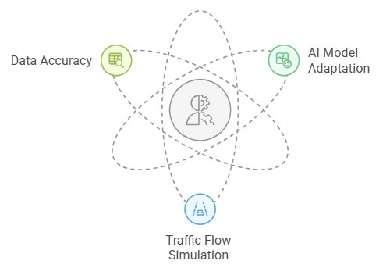

Figure 7: Key challenges in implementing urban traffic management systems

## **7.4 Functional and Non-Functional Requirements**

The functional and non-functional requirements define the system's behavior and quality attributes, forming the foundation for development.

### **7.4.1 Functional Requirements (FR)**

1. The system must allow traffic operators to monitor real-time traffic data.
2. The system must enable users to view traffic signal statuses for different intersections.
3. The system must allow operators to adjust traffic signals manually.
4. The system must provide visualizations of traffic predictions for specified time intervals.
5. The system must send alerts to operators for anomalies such as accidents or unusual traffic patterns.
6. The system must provide access to system settings for emergency mode configurations.
7. The system must provide live traffic data, predictive analysis, and event alerts.
8. The system must collect real-time traffic data from sensors, including vehicle and pedestrian counts.
9. The system must process sensor data locally on edge devices to detect anomalies.
10. The system must send sensor data to the cloud for aggregation and analysis.
11. The system must dynamically adjust traffic lights based on sensor data.
12. The system must integrate emergency vehicle systems with traffic signals to prioritize their movement.
13. The system must identify and classify vehicles and pedestrians using sensors and cameras.
14. The system must provide adaptive timings to enhance crosswalk safety.
15. The system must detect emergency vehicles and adjust lights for quicker passage.
16. The system must use weather and road data for better decision-making.
17. The system must simulate real-world traffic conditions based on input from IoT sensors.
18. The system must allow operators to test and evaluate traffic management strategies virtually.
19. The system must support dynamic adjustments to simulation variables such as vehicle count, weather, and signal timings.
20. The system must analyze real-time traffic data for anomalies.
21. The system must visualize simulation results for operators to compare with physical traffic data.
22. The system must simulate traffic scenarios to test strategies before implementation.
23. The system must use AI to predict traffic and adapt to changes.
24. The system must combine data from the physical model and digital twin for unified traffic management.
25. The system must provide an interface to switch between real-time monitoring and simulation modes.
26. The system must trigger changes across all components (e.g., signals, simulations) in response to emergency alerts.
27. The system must synchronize data from the physical model with the digital twin in real time.
28. The system must allow operators to download historical traffic data and reports.
29. The system must adjust traffic light timings in real-time based on live data.

### **7.4.2 Non-Functional Requirements (NFR)**

#### Usability:

* 90% of users (including traffic managers) should be able to use the system without extensive training.
* The interface should be intuitive and user-friendly, allowing 90% of users to perform basic operations without assistance.

#### Performance:

* User interface response time must be ≤ 1 second for displaying real-time traffic data.
* Live traffic monitoring system should update traffic data every ≤ 500 milliseconds.
* Alert systems must send notifications within ≤ 100 milliseconds of event detection.
* Traffic visualization loading time (graphs, maps) must be ≤ 2 seconds after data reception.
* Real-time simulation processing time must be ≤ 200 milliseconds per computation cycle.
* AI-based traffic prediction processing time must be ≤ 300 milliseconds for congestion forecasting.
* User interface loading time under a load of 100 concurrent usersmust be ≤ 1.5 seconds.

#### Reliability:

* The data management system must have 99.9% uptime, excluding scheduled maintenance.

#### Scalability:

* System upgrades must be performed without downtime, with a maximum outage time of ≤ 5 minutes.

#### Security:

* All data transmissions between system components must be encrypted using AES-256 with TLS 1.3 support.
* All authorized users must be required to use multi-factor authentication (MFA) for all access points.

#### Data Integrity:

* Synchronization accuracy between the digital twin and the physicalsystem must be ≥ 99.5%.

#### Adaptability:

* The interface must be accessible on desktops, tablets**,** and smartphones, ensuring 100% compatibility with modern browsers.

#### Interactivity:

* The system must automatically detect emergency vehicles and adjust traffic lights within ≤ 1 second of detection.

#### Integration:

* The system must integrate real-time weather and road condition data and adjust traffic light timing within ≤ 2 seconds.

#### System Compatibility:

* The system must maintain full compatibility with standard APIs and enable seamless integration with existing traffic management systems.

## **7.5 Use Case Diagram**

*Figure 8: Use Case Diagram*

# 

# **8. Design and Development**

The design and development stage is critical for transforming the theoretical framework into a practical, functioning solution. Here, the system's architecture is visualized, and essential components such as IoT, AI, and simulation technologies are integrated to achieve the desired outcomes.

## **8.1 Visualizing the System Architecture: Diagrams and Flowcharts**

To begin, we visualize the system’s architecture using diagrams and flowcharts. This allows us to understand the structure of the system and how different components will interact to deliver efficient traffic management.

### **8.1.1 General Architecture for Digital Twins in Onshape**

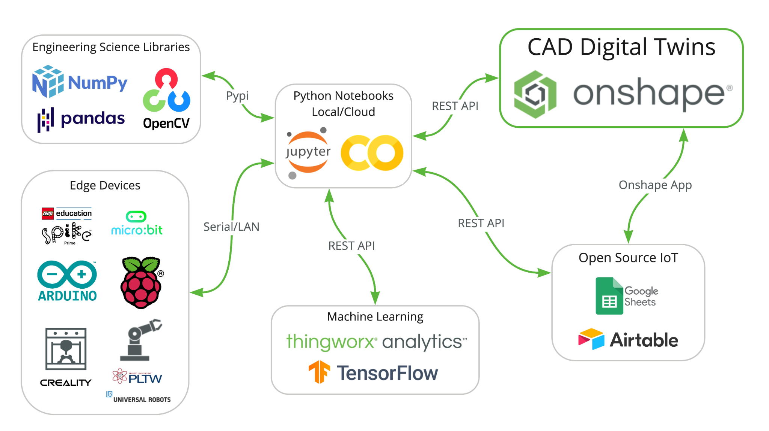

*Figure 9 :General Architecture: Digital Twins and IoT Integration Framework [30]*

This architecture (in figure 9) demonstrates the integration of CAD Digital Twins using Onshape alongside Python-based data analysis, edge devices, and machine learning capabilities. The system is designed to facilitate IoT-enabled workflows, real-time data visualization, and predictive analytics.

### Key Components and Their Roles:

1. CAD Digital Twins (Onshape)  
   Onshape serves as the central platform for creating virtual models of physical systems, enabling real-time visualization, monitoring, and optimization. It integrates with Python-based systems and IoT platforms via REST APIs for real-time updates.
2. Python Notebooks (Local or Cloud)  
   Jupyter Notebooks or Google Colab act as the control hub, handling data processing, analysis, and communication between edge devices, machine learning models, and IoT dashboards using libraries like NumPy, Pandas, and OpenCV.
3. Edge Devices  
   Microcontrollers (Arduino, Raspberry Pi), robotics, and sensors collect real-time physical data (e.g., temperature, motion, performance) and transmit it to Python notebooks for processing and feedback.
4. Machine Learning Platforms  
   Tools like ThingWorx Analytics and TensorFlow analyze data, providing insights on failure detection, performance optimization, and system improvements. These insights update the Digital Twin, are visualized in Python, or sent to IoT platforms.
5. Open Source IoT Platforms  
   Google Sheets and Airtable store, log, and visualize system data. Python scripts ensure seamless communication via REST APIs for synchronized monitoring and analysis.

8.1.2 Our Project System Architecture

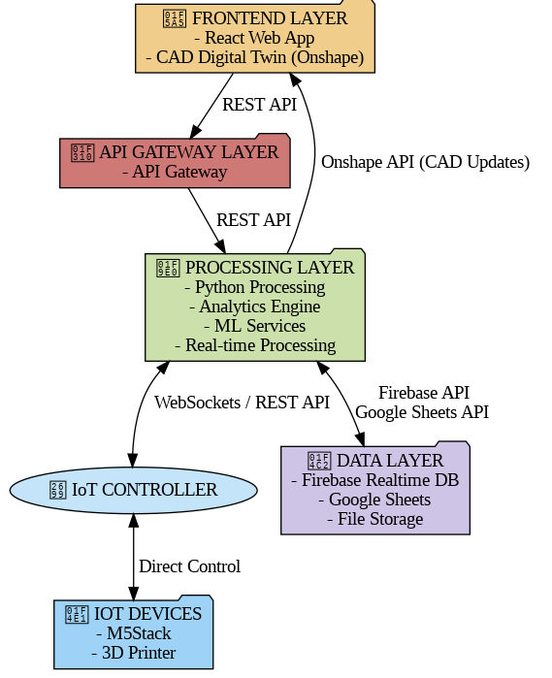

*Figure 10 :System Architecture*

### **8.1.2 The architecture involves the following workflows:**

1. Data Flow: Sensors collect data → Edge devices preprocess and transmit it → Cloud processes the data → AI models analyze and output controls → Traffic lights adjust in real-time.
2. Digital Twin Integration: Sensors and AI models provide data → REST APIs synchronize data → Digital Twin in Onshape reflects real-time simulations and optimizations.
3. Web Interface: System data (traffic, weather, alerts) → Dynamic webpage visualizes information → Users monitor and interact with the system.

## **8.1.3 Activity Diagram :**

*Figure 11 :Activity Diagram*

## **8.2 Implementation of IoT and Sensors**

Building on the system architecture, the next step involves integrating IoT devices and sensors. These devices will gather critical real-time data that will drive decision-making within the system, helping to optimize traffic flow and safety.

### **8.2.1 IoT Device Integration with Traffic Systems**

Edge devices such as M5Stack Core are configured to manage connected IoT sensors and traffic lights. They transmit data to the cloud for advanced analysis and act as actuators to implement AI-driven traffic signal adjustments. However, these sensors are intended for prototyping purposes only and are not suitable for large-scale urban deployments due to limitations in processing power, communication capabilities, and reliability under real-world conditions. For full-scale implementation, industrial-grade IoT solutions with higher durability, greater data processing capacity, and support for more robust communication protocols—such as 5G, LoRaWAN, or Edge AI Computing—would be required.

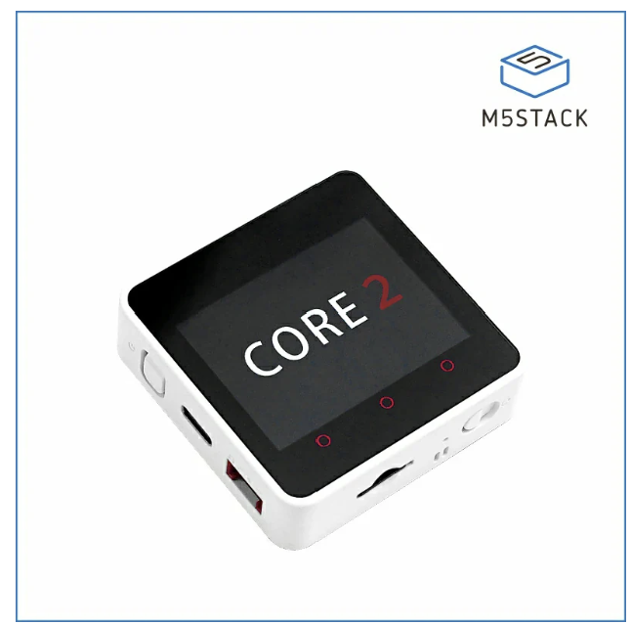

*Figure 12 :M5Stack Core2 Controller[31]*

### **8.2.2 Sensor Placement and Calibration for Data Accuracy**

* Mini Camera**:** Placed at the middle of the intersection for a clear view of vehicle and pedestrian movements.

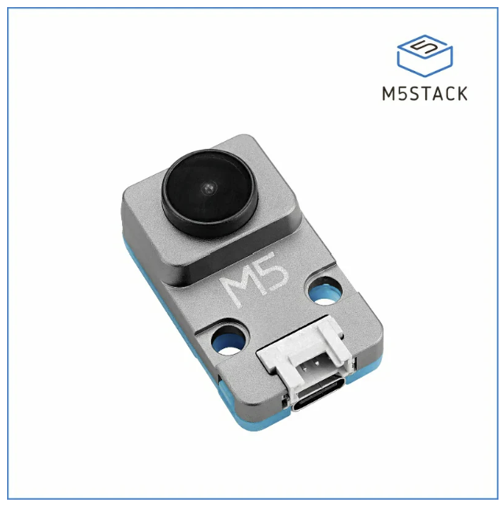

*Figure 13 :UnitV K210 AI Camera M12 Version[31]*

* Weight Sensors**:** Installed on road lanes to identify vehicle types and monitor road load.

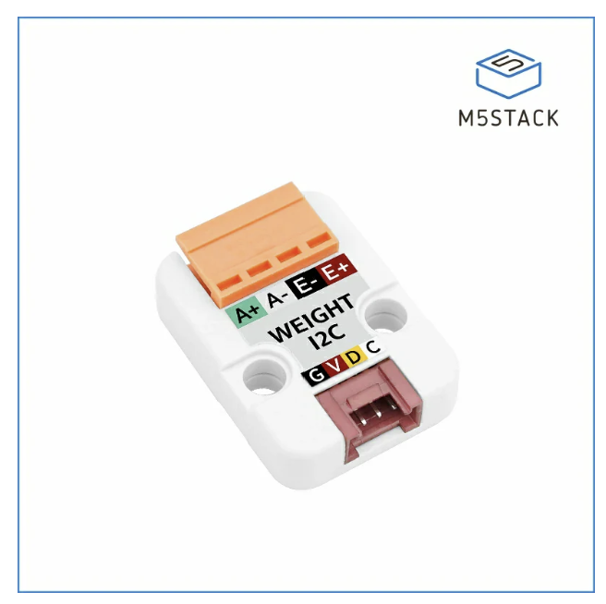

*Figure 14 :Weight I2C Unit[31]*

* Ultrasonic Sensors: Positioned near intersections to measure vehicle gaps and monitor queue lengths.

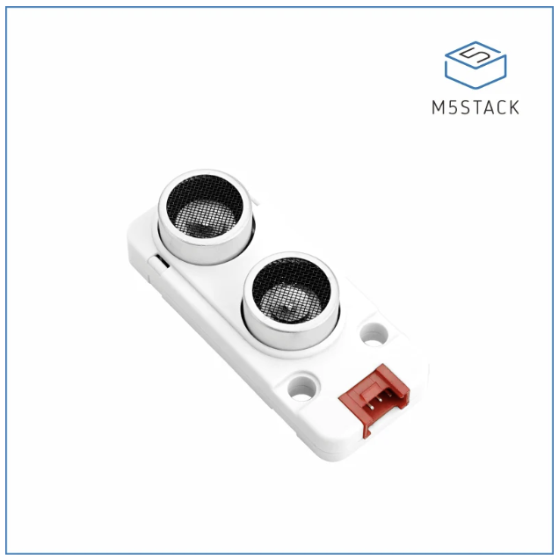

*Figure 15 :Ultrasonic Distance Unit I2C[31]*

Sensors are calibrated regularly to ensure accurate data collection, minimizing errors in AI model predictions and signal adjustments.

## **8.3 AI Model Development**

With the data gathered from IoT devices, AI models are developed to analyze and optimize the traffic management system. These models will make real-time decisions, such as adjusting signal timings based on traffic conditions and environmental factors.

To optimize the decision-making process for traffic signal management, we integrate advanced machine learning techniques that leverage both historical and real-time traffic data.

1. ARIMA and Linear Regression Models: These models are employed to predict traffic volumes by analyzing time-series data, allowing the system to forecast traffic patterns and adjust signal timings accordingly. ARIMA, with its ability to account for seasonality and trends in traffic flow, is particularly useful for predicting peak and off-peak traffic periods. Linear regression complements this by establishing a relationship between traffic volume and time of day, enhancing the accuracy of predictions.
2. Haar Cascades and HOG + SVM for Dynamic Detection: A combination of Haar Cascade classifiers and Histogram of Oriented Gradients (HOG) with Support Vector Machine (SVM) is utilized for pedestrian and vehicle detection. This dynamic detection mechanism allows the system to accurately identify and track moving objects at intersections, providing real-time data that helps optimize traffic signal timings based on the presence and movement of pedestrians and vehicles.

### **8.3.2 Rule-Based and Statistical Approaches in Real-Time Signal Adjustments**

In addition to machine learning models, we incorporate rule-based and statistical methodologies to further enhance real-time signal adjustment and ensure the system operates efficiently under varying traffic conditions.

1. Rule-Based Systems and Genetic Algorithms: Rule-based systems are used to define traffic signal timings based on predefined rules, such as time-of-day, vehicle volume thresholds, and pedestrian crossing priorities. To refine the timing decisions further, we apply Genetic Algorithms (GAs), which use evolutionary techniques to evaluate multiple signal timing configurations and select the most optimal one based on performance metrics, such as traffic throughput and wait times.
2. Z-Score and k-Means Clustering for Anomaly Detection: To ensure the reliability and robustness of the system, we use Z-score analysis and k-Means clustering to detect anomalies in traffic patterns. Z-scores help identify traffic data points that deviate significantly from expected values, while k-Means clustering groups similar traffic data, allowing the system to recognize and address unusual traffic scenarios or sensor malfunctions, ensuring smooth operation and reducing the likelihood of system failures.

## **8.4 Digital Twin Simulation**

To validate the AI models and test different scenarios, digital twin technology is used to simulate virtual traffic environments. These simulations help in fine-tuning the system before it is deployed in real-world conditions.

The Digital Twin in Onshape replicates real-world intersections virtually, simulating interactions between vehicles, pedestrians, and traffic signals. Data collected from IoT sensors and AI models is integrated via REST APIs, enabling a real-time comparison of physical and virtual systems.

### **8.4.1 Simulation Scenarios and Benchmarks**

The system is evaluated through various simulation scenarios to ensure its robustness and effectiveness under different traffic conditions ,Simulations include:

1. Peak-Hour Traffic Management: Validate RL-based signal optimizations under heavy traffic.
2. Emergency Vehicle Adaptations: Assess how the system responds to emergency scenarios.
3. Anomaly Detection Benchmarks: Test the sensitivity of unsupervised models to unusual traffic patterns.  
   Key metrics such as average wait times, throughput, and safety incident rates are monitored.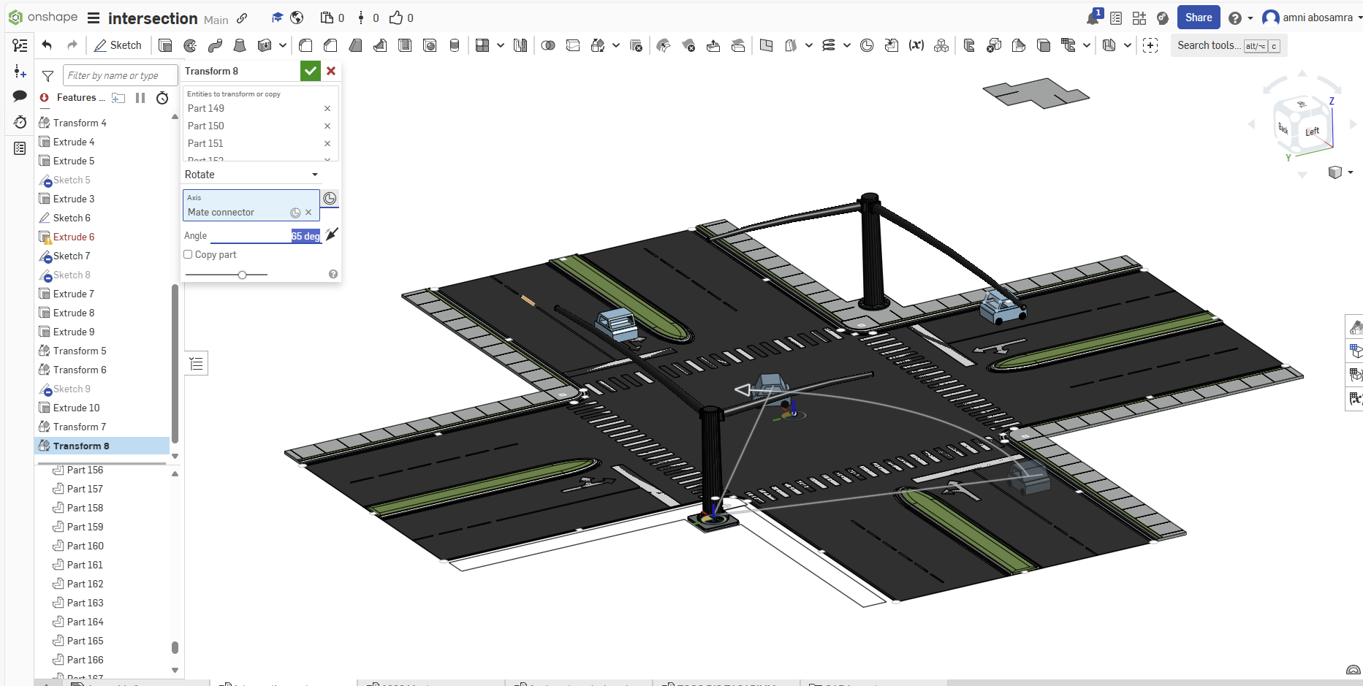

*Figure16 : OnShape model*

## **8.5 Web Interface for Traffic and Environmental Data**

The system incorporates a web-based dashboard designed to provide real-time insights into traffic and weather conditions at intersections, ensuring operators can monitor and manage traffic efficiently. The dashboard includes the following key features:

1. Traffic Data Visualization: The dashboard provides real-time updates on vehicle and pedestrian counts, signal states, and queue lengths. This data is visually represented through interactive charts and graphs, allowing for quick assessment of traffic flow and congestion at any given moment.
2. Weather Data Integration: To enhance traffic management, the system integrates weather data from external APIs, such as OpenWeatherMap. This allows for the display of relevant local conditions, including rainfall, temperature, and visibility, which may influence traffic behavior and signal timing adjustments.
3. System Alerts: The dashboard features a robust alert system that notifies operators of anomalies, hardware malfunctions, or emergency scenarios. These alerts help ensure timely responses to potential issues, improving overall system reliability and safety.
4. User Interface: The dashboard is designed with a fully responsive layout, ensuring it provides a seamless user experience across various devices, including desktops, tablets, and smartphones. This accessibility ensures that traffic management teams can monitor and control the system from anywhere, at any time.

Data is fetched using REST APIs, ensuring consistent and accurate visualization for both operators and end-users.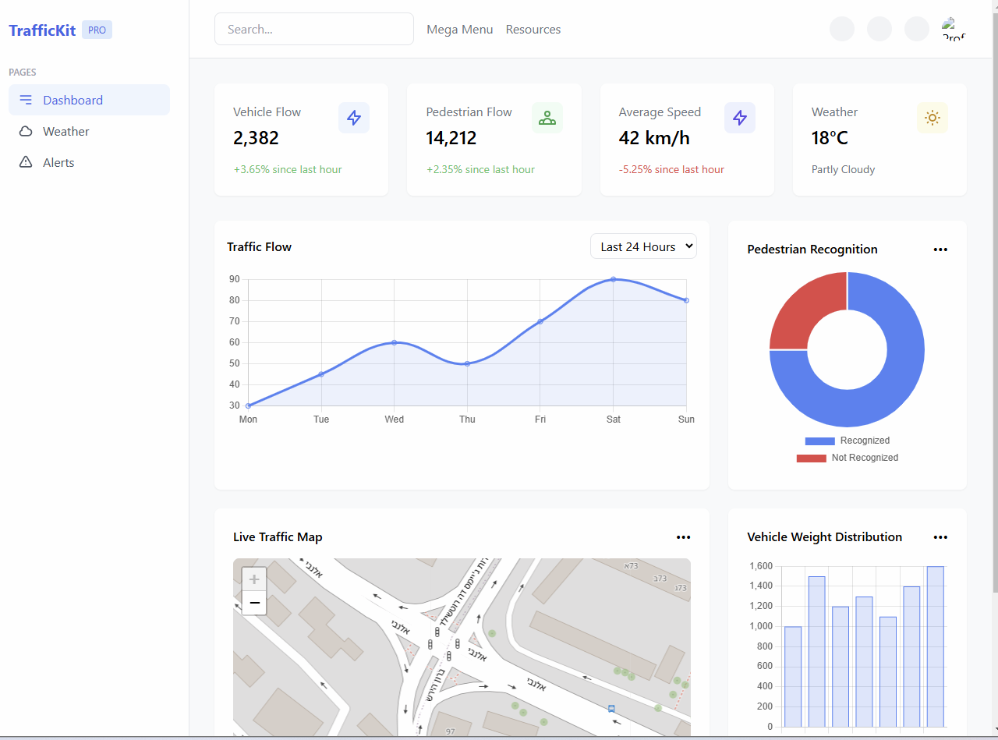

# 

*Figure 16 :GUI*

# 

# 

*Figure 17 :GUI*

# **9. Verification and Evaluation**

To ensure the reliability and effectiveness of the system, a comprehensive verification process is implemented. This involves rigorous testing at multiple levels, from individual components to full system integration, ensuring that all functionalities operate as expected under real-world conditions.

## **9.1 Evaluation**

The system evaluation will be based on its ability to optimize traffic light operations in real-time through continuous data analysis and the utilization of AI and machine learning algorithms.

The system will be assessed according to the following key criteria:

1. Accuracy of traffic prediction and improvement of traffic flow.
2. Reduction in waiting times at traffic lights during peak hours.
3. Enhancement of pedestrian safety through adaptive signaling.
4. Optimization of energy consumption by dynamically adjusting traffic light operations based on demand.
5. Adaptation to emergency situations, including emergency vehicle detection and priority signal adjustments.
6. Web application synchronization with Onshape to ensure real-time visualization of traffic conditions.

## **9.2 Verification**

### **9.2.1 Testing Plan**

The development process will follow an iterative approach and will be divided into four main phases:

1. IoT Sensors and Data Collection – Ensuring the reliability and accuracy of the gathered data.
2. Traffic Prediction and Optimization Algorithm – Machine learning-based testing, prediction accuracy analysis, and performance improvements.
3. User Interface and Dashboard – Usability testing, user experience evaluation, and data visualization accuracy.
4. Web Application and Onshape Integration – Ensuring seamless communication, data accuracy, and visualization consistency.

#### Unit Testing

1. Python pytest/unittest – Testing the decision-making logic of the system.
2. API Testing – Ensuring seamless communication between IoT components, AI processing units, the dashboard, and the web application.

#### Integration Testing

1. Sensor Communication Testing – Verifying proper data transmission between traffic sensors, cameras, and the central server.
2. Decision-Making Testing – Ensuring the system dynamically adjusts traffic light timings based on real-time conditions.
3. Extreme Scenario Testing – Evaluating system performance under abnormal traffic loads, sensor failures, and emergency vehicle detection.
4. Web Application Synchronization – Ensuring that the real-time data from IoT sensors and Onshape simulations are reflected accurately in the web application.

#### System Testing

1. Simulations – Running tests using Onshape and Python to simulate real-world scenarios.
2. Performance Metrics – Monitoring response time and real-time data processing efficiency.
3. Web Application Performance – Ensuring smooth operation under high user loads and fast rendering of real-time traffic data.
4. Security Measures – Ensuring data protection and encryption for secure communication between system components.

## **9.3 Test Cases**

| **Test ID** | **Module** | **Tested Function** | **Expected Result** |
| --- | --- | --- | --- |
| 1 | IoT Sensors | Vehicle Detection | Accurate vehicle detection (≥95%) |
| 2 | IoT Sensors | Pedestrian Detection | Detect pedestrians in all lighting conditions |
| 3 | AI System | Traffic Prediction | Predict congestion with >85% accuracy |
| 4 | AI System | Signal Timing Optimization | Reduce average wait time by >20% |
| 5 | AI System | Emergency Vehicle Handling | Clear emergency lanes in <3s |
| 6 | System | API Communication | Reliable data exchange between sensors and servers |
| 7 | System | Response Time | Process live traffic data in <1s |
| 8 | System | Traffic Light Control | Smooth signal transition with minimal disruption |
| 9 | Web Application | Real-time Data Synchronization | Updates in Web UI reflect Onshape changes in <2s |
| 10 | Web Application | API Communication | Web receives correct real-time data from Onshape |
| 11 | Web Application | User Interface Responsiveness | UI updates dynamically without manual refresh |
| 12 | Performance | Stress Test | Handle peak traffic conditions without failure |

# **10. AI Tools and Prompts**

During our work on phase a, we used AI tools such as: ChatGPT, Claude, Floats and Scispace. We used these different AI tools in a variety of areas such as checking syntax and spelling, conducting literature introduction research as well as in the practical part to check on various technologies and methods.

**11.1 Prompts Used**

1. Prompt: How can I efficiently search for relevant academic papers on Google Scholar?

Answer: It is recommended to use precise keywords and incorporate Boolean operators such as "Digital Twin" AND "Traffic Management" to refine search results. Additionally, filtering results by citation count, setting a date range, and reviewing references in leading papers can help identify relevant research

1. Prompt: How can I verify if an academic paper is credible and relevant?

Answer: It is important to check the publication source (peer-reviewed journals or international conferences), citation count (a high number often indicates significant impact), and the authors' credentials (recognition in the field). Furthermore, the study should be based on recent data and provide a thorough analysis rather than just a general review.

1. Prompt: How can I generate an APA-formatted reference list automatically?

Answer: Tools like Zotero, Mendeley, or Google Scholar (using the "Cite" option) can generate references automatically. Additionally, Google Docs has a built-in citation management tool under "Tools" > "Citations", where users can select APA (6th/7th edition) and create a properly formatted reference list.

1. Prompt: How can I ensure that my paper is clear and well-structured?

Answer: Using text editing tools such as Grammarly or Hemingway Editor can help identify grammar errors and improve readability. Additionally, reading the text aloud can help spot awkward phrasing. Having a peer review the text and provide feedback is also beneficial.

# **11. References:**

1. Trustify Technology. (n.d.). How digital twins shape smart traffic. Retrieved January 8, 2025, from

<https://trustifytechnology.com/news/how-digital-twins-shape-smart-traffic/>

1. Federal Highway Administration, Developing Future Traffic Management Systems Using Hybrid Twins (Washington, DC: 2022)

<https://doi.org/10.21949/1521929>.

1. Javaid, M., Haleem, A., & Suman, R. (2023). Digital Twin applications toward Industry 4.0: A Review. *Cognitive Robotics*, *3*, 71–92. <https://doi.org/10.1016/j.cogr.2023.04.003>
2. Negri, E., Fumagalli, L., & Macchi, M. (2017). Digital Twin applications: A review. *Proceedings of the 27th International Conference on Flexible Automation and Intelligent Manufacturing*, 731–740.

<https://doi.org/10.1016/j.promfg.2017.07.273>

1. Liu, C., Zhang, P., & Xu, X. (2023). Literature review of digital twin technologies for civil infrastructure. *Journal of Infrastructure Intelligence and Resilience*, *2*(3), 100050.

<https://doi.org/10.1016/j.iintel.2023.100050>

1. Soori, M., Arezoo, B., & Dastres, R. (2023). Digital twin for smart manufacturing, A review. *Sustainable Manufacturing and Service Economics*, *2*, 100017.

<https://doi.org/10.1016/j.smse.2023.100017>

1. F. Pires, A. Cachada, J. Barbosa, A. P. Moreira and P. Leitão, "Digital Twin in Industry 4.0: Technologies, Applications and Challenges," *2019 IEEE 17th International Conference on Industrial Informatics (INDIN)*, Helsinki, Finland, 2019

<https://ieeexplore.ieee.org/abstract/document/8972134>

1. *Digital Twin: enabling technologies, challenges and open research*. (2020). IEEE Journals & Magazine | IEEE Xplore.

<https://ieeexplore.ieee.org/document/9103025>

1. S. Shahana, R. Revathi, P. Sowmya, D. Dhanalakshmi, S. Mandala and S. Hariharan, "Traffic Signal Automation by Sensing and Detecting Traffic Intensity Through IR Sensors," 2023 International Conference on Sustainable Emerging Innovations in Engineering and Technology (ICSEIET), Ghaziabad, India,

<https://ieeexplore.ieee.org/stamp/stamp.jsp?tp=&arnumber=10303291&isnumber=10303030>

1. C. Güven, Ö. Karaduman and E. Avci, "A Review on Urban Intelligent Traffic Management Problems: Sensors and Methods," *2021 2nd International Informatics and Software Engineering Conference (IISEC)*, Ankara, Turkey, 2021.

<https://ieeexplore.ieee.org/stamp/stamp.jsp?tp=&arnumber=9672412&isnumber=9672333>

1. Parekh, S., Dhami, N., Patel, S., Undavia, J. (2019). Traffic Signal Automation Through IoT by Sensing and Detecting Traffic Intensity Through IR Sensors. In: Satapathy, S., Joshi, A. (eds) Information and Communication Technology for Intelligent Systems . Smart Innovation, Systems and Technologies, vol 106. Springer, Singapore.

<https://doi.org/10.1007/978-981-13-1742-2_6>

1. M. T. Ubaid, T. Saba, H. U. Draz, A. Rehman, M. U. Ghani khan and H. Kolivand, "Intelligent Traffic Signal Automation Based on Computer Vision Techniques Using Deep Learning," in *IT Professional*

<https://ieeexplore.ieee.org/stamp/stamp.jsp?tp=&arnumber=9717356&isnumber=9717307>

1. Liu, H., & Li, K. (2019). *A survey on traffic management and control for connected vehicles*. arXiv.

<https://arxiv.org/pdf/1904.06656>

1. Devi, S. S. L. M. L., Gupta, D. N., & Singh, A. K. (2021). *IoT based intelligent Traffic Management and Violators Recognition system*. <https://papers.ssrn.com/sol3/papers.cfm?abstract_id=3879988>
2. F. Zhu, Y. Lv, Y. Chen, X. Wang, G. Xiong and F. -Y. Wang, "Parallel Transportation Systems: Toward IoT-Enabled Smart Urban Traffic Control and Management," in *IEEE Transactions on Intelligent Transportation Systems ,*<https://ieeexplore.ieee.org/document/8824092>
3. Taylor, J. I. (2024, November 12). *Florida Policy Project: Outdated traffic signals have Florida lagging on road efficiency, safety*. Florida Politics - Campaigns & Elections. Lobbying & Government. <https://floridapolitics.com/archives/707357-florida-policy-project-outdated-traffic-signals-have-florida-lagging-on-road-efficiency-safety/>
4. *Traffic lights: For safety and efficiency on our roads*. Retrieved from<https://arxiv.org/pdf/2408.11649v1>
5. *Traffic lights: For safety and efficiency on our roads* (arXiv:2408.11649v1). Retrieved

<https://arxiv.org/pdf/2408.11649v1>

1. JMDK, H., LMR, W., TR, W., SJASMS, J., Krishara, J., & Chandrasiri, S. (2023). Smart Crosswalk: Machine Learning and Image Processing based Pedestrian and Vehicle Monitoring System. *International Journal of Artificial Intelligence & Applications*, *14*(6), 21–35.

<https://doi.org/10.5121/ijaia.2023.14603>

1. Biswas, S., Ghosh, I., & Chandra, S. (2017). Effect of traffic signal countdown timers on pedestrian crossings at signalized intersection. *Transportation in Developing Economies*, *3*(1).

<https://doi.org/10.1007/s40890-016-0032-7>

1. Dettinger, F., Weiß, M., Dittler, D., Stümpfle, J., Artelt, M., & Weyrich, M. (2024). A survey on performance, current and future usage of Vehicle-To-Everything Communication Standards. *arXiv (Cornell University)*. <https://doi.org/10.48550/arxiv.2410.10264>
2. Texas A&M Transportation Institute. (n.d.). *Traffic management centers: Technical summary*. Texas A&M University. Retrieved January 27, 2025, from<https://mobility.tamu.edu/mip/strategies-pdfs/traffic-management/technical-summary/traffic-management-centers-4-pg.pdf>
3. Qin, Y., Liu, C., Xie, L., & Tang, H. (2024). Dynamic optimal lane management strategy for multi-lane urban expressway with bi-class connected vehicles. *Urban Lifeline*, *2*(1).

<https://doi.org/10.1007/s44285-024-00029-w>

1. Adebayo, O. T., & Alhassan, H. (2023). *Network traffic prediction using AI to predict and manage traffic in high-demand IT networks*. ResearchGate. Retrieved January 27, 2025, from<https://www.researchgate.net/publication/387334734_NETWORK_TRAFFIC_PREDICTION_USING_AI_TO_PREDICT_AND_MANAGE_TRAFFIC_IN_HIGH-DEMAND_IT_NETWORKS>
2. Zhang, J., & Li, X. (2018). *Smart intersections and roads for autonomous and connected vehicles: Workshop module 3, Autonomous intersection management*. ResearchGate. Retrieved January 27, 2025, from<https://www.researchgate.net/publication/335827727_Smart_Intersections_and_Roads_For_Autonomous_and_Connected_Vehicles_Workshop_Module_3_Autonomous_Intersection_Management>
3. Galea, E., Xie, H., & Lawrence, P. (2014). Experimental and survey studies on the effectiveness of dynamic signage systems. *Fire Safety Science*, *11*, 1129–1143.

<https://doi.org/10.3801/iafss.fss.11-1129>

1. ADL. (n.d.). *Integrated mobility platforms: Transforming urban mobility with customer-tailored solutions*. Arthur D. Little. Retrieved January 27, 2025, from<https://www.adlittle.com/en/insights/viewpoints/integrated-mobility-platforms#:~:text=Integrated%20Mobility%20Platforms%20(IMPs)%20are,provide%20highly%20customer%2Dtailored%20solutions>
2. Baggag, A., Al-Homaid, A. Y., Zanouda, T., & Aupetit, M. (2018). Deep Learning for Traffic Analytics Application FIFA2022. *Qatar Foundation Annual Research Conference Proceedings Volume 2016 Issue 1*. <https://doi.org/10.5339/qfarc.2018.ictpd544>
3. Valarmathi, V., & Dhanalakshmi, S. (2024). Internet of Traffic Surveillance System (IOTSS) with genetic algorithm for Optimized Weather-Adaptive Traffic Monitoring. In *Advances in computational intelligence and robotics book series* (pp. 1–25).

<https://doi.org/10.4018/979-8-3693-5276-2.ch001>

1. PTC. (n.d.). *Onshape digital twins: Digital transformation in education*. PTC Education. Retrieved January 30, 2025, from<https://ptc-education.github.io/docs/solutions/onshapedx>
2. M5Stack**.** (n.d.). *M5Stack – Modular IoT Development Kits*. Retrieved February 2, 2025, from

<https://m5stack.com/>

1. Cisco. (n.d.). *Bandwidth management for Board, Desk, and Room Series*. Cisco Webex Help Center. Retrieved from <https://help.webex.com/en-us/article/51qu5cb>
2. Cisco. (n.d.). *What are the Minimum Bandwidth Requirements for Sending and Receiving Video in Cisco Webex Meetings*. Cisco Webex Help Center. [Retrieved from https://help.webex.com/en-us/article/WBX22158](https://help.webex.com/en-us/article/WBX22158)
3. Reolink. (n.d.). *IP Camera Bandwidth Calculator: Formula, Example & Tips*. Reolink Blog. Retrieved from <https://reolink.com/blog/ip-camera-bandwidth-calculation/>
4. Telnyx. (n.d.). *Real-world applications of IoT for traffic monitoring*. Telnyx Resources. Retrieved from

<https://telnyx.com/resources/iot-monitoring-traffic>

1. KORE Wireless. (n.d.). *IoT Monitor Traffic: A Smart Approach*. KORE Wireless News. Retrieved from <https://www.korewireless.com/news/iot-monitor-traffic>
2. Cisco. (n.d.). *Bandwidth Planning in your Cisco Webex Meetings Environment*. Cisco. Retrieved from <https://www.cisco.com/c/en/us/products/collateral/conferencing/webex-meetings/white_paper_c11-691351.html>
3. State Tech Magazine. (2018, December). *Smart Cities Gain Efficiencies from IoT Traffic Sensors and Data*. StateTech Magazine. Retrieved from <https://statetechmagazine.com/article/2018/12/smart-cities-gain-efficiencies-iot-traffic-sensors-and-data-perfcon>
4. Chen, Y., Li, X., & Zhang, Z. (2021). *Machine Learning Applications in Traffic Management: A Review*. Transportation Research Part C: Emerging Technologies, 124, 102932.
5. Zhang, H., & Wang, Y. (2020). *Real-Time Traffic Signal Control Using Reinforcement Learning and Sensor Data*. IEEE Transactions on Intelligent Transportation Systems, 21(3), 1254-1265.
6. Gupta, R., Kumar, P., & Singh, A. (2019). *Adaptive Traffic Light Control System Using Machine Learning Techniques*. Journal of Traffic and Transportation Engineering, 6(2), 210-223.